|  |  |
| --- | --- |
| arima modeling of india’s external debt | **PSIFIOLEXI R-1**  TEAM  LEADER – 20BDA05 RESHMA DUA  20BDA21 JOEL BHARAT MONIS  20BDA29 GIRISHA MANOCHA  20BDA48 PRAJJWAL PATEL |

**CONTENTS**

|  |  |  |
| --- | --- | --- |
| **Sl No** | **Topic** | **Pg No** |
| 1 | A Short Introduction to ARIMA | 2 |
| 2 | India’s External Debt | 3 |
| 3 | India’s External Debt Dataset from RBI | 3 |
| 4 | Description of Variables | 3 |
| 5 | Process of Modeling | 5 |
| 6 | Activities | 5 |
| 7 | Visuals and Data | 6 |
| 8 | Appendix A - Plots of all variables of the RBI Dataset | 7 |
| 9 | Appendix B - Key checkpoint data for each variable | 11 |
| 10 | References | 15 |

**INTRODUCTION**

1. **A Short Introduction to ARIMA.**

(a) ARIMA models are a popular and flexible class of forecasting model that utilize historical information to make predictions. This type of model is a basic forecasting technique that can be used as a foundation for more complex models.

(b) ARIMA stands for auto-regressive integrated moving average and is specified by these three order parameters: *(p, d, q)*. ARIMA forecasting algorithm is based on the idea that the information in the past values of the time series, i.e its own lags and the lagged forecast errors alone can be used to forecast future values. The process of fitting an ARIMA model is sometimes referred to as the Box-Jenkins method.

(c) An**auto regressive (AR(p))** component is referring to the use of past values in the regression equation for the series Y. The auto-regressive parameter p specifies the number of lags used in the model. For example, AR(2) or, equivalently, ARIMA(2,0,0), is represented as

where φ1, φ2 are parameters for the model.

(d) The d represents the degree of differencing in the **integrated (**I(d)**)** component. Differencing a series involves simply subtracting its current and previous values d times. Often, differencing is used to stabilize the series when the stationarity assumption is not met.

(e) A **moving average (MA(q))** component represents the error of the model as a combination of previous error terms et. The order q determines the number of terms to include in the model.

(f) Differencing, autoregressive, and moving average components make up a non-seasonal ARIMA model which can be written as a linear equation:



where yd is Y differenced d times and c is a constant.

(f) ARIMA methodology does have its limitations. These models directly rely on past values, and therefore work best on long and stable series. Also note that ARIMA simply approximates historical patterns and therefore does not aim to explain the structure of the underlying data mechanism.

2. **India’s External Debt.** The external debt of India is the total debt the country owes to foreign creditors. The debtors can be the Union government, state governments, corporations or citizens of India. The debt includes money owed to private commercial banks, foreign governments, or international financial institutions such as the International Monetary Fund (IMF) and World Bank.

3. **India’s External Debt Dataset from RBI.** The Reserve Bank of India (RBI) has rich traditions of publishing data on various aspects of the Indian Economy through several of its publications. Through its website (DBIE), data are mainly presented through time-series formatted reports. These reports have been organized under sectors and sub-sectors according to their periodicities. The External Debt Dataset used in this project is a Time Series Data on India’s external debt from 1991 to 2020. The dataset contains 64 features which have been categorised into 12 broad categories which are as given below :-

1. Total Multilateral Debt
2. Total Bilateral Debt
3. IMF Loans
4. Total Trade Credit
5. Total Commercial Borrowing
6. NRI and FC Deposit
7. Total Rupee Debt
8. Total Long Term Debt
9. Total Short Term Debt
10. Gross Total Debt
11. Debt Stock GDP Ratio
12. Debt Service Ratio

4. **Description of Variables.**

1. **Total Multilateral Debt.** Multilateral debt is the money India owes to international financial institutions such as the Asian Development Bank (ADB), the International Development Association (IDA), the International Bank for Reconstruction and Development (IBRD), the International Fund for Agricultural Development (IFAD) and others. Borrowing from the International Monetary Fund (IMF) are not included under multilateral debt, and are instead classified separately under the IMF head. The country's major creditors are the IDA, ADB, and IBRD. The IFAD and a few other multilateral creditors hold the remaining portion of the multilateral debt.
2. **Total Bilateral Debt.** Bilateral debt is the money India owes to foreign governments.
3. **IMF Loans.** The International Monetary Fund, or IMF, promotes international financial stability and monetary cooperation. It also facilitates international trade, promotes employment and sustainable economic growth, and helps to reduce global poverty through loans. The IMF is governed by and accountable to its 190 member countries.
4. **Total Trade Credit.** Trade credit is the amount of short-term loans provided by suppliers to their customers upon purchase of their products. It is automatically created when the customers delay payment of bills to their suppliers.
5. **Total Commercial Borrowings.** Commercial Borrowing is the loan/ debt/ borrowings taken by an eligible entity in India for commercial purpose, externally i.e. from any recognized entity outside India. However, these borrowings taken must confirm with norms of the Reserve Bank of India (RBI).
6. **NRI and FC Deposit.** These deposits are Foreign Currency Non-Resident Fixed Deposits offered to NRIs as a significant way of attracting remittances from NRIs.
7. **Total Rupee Debt.** Rupee debts are debts to be paid in rupees to foreigners by Indian residents.
8. **Total Long Term Debt.** Long-term debt is debt that matures in more than one year.
9. **Total Short Term Debt.** Short-term debt includes all debt having an original maturity of one year or less and interest in arrears on long-term debt.

(j) **Gross Total Debt.** Gross debt is the sum of Total Long Term Debt and Total Short Term Debt.

(k) **Debt Stock GDP Ratio.** The debt-to-GDP ratio is the metric comparing a country's public debt to its gross domestic product (GDP). By comparing what a country owes with what it produces, the debt-to-GDP ratio reliably indicates that particular country’s ability to pay back its debts. Often expressed as a percentage, this ratio can also be interpreted as the number of years needed to pay back debt, if GDP is dedicated entirely to debt repayment. Because debt is a stock rather than a flow, it is measured as of a given date, usually the last day of the fiscal year.

(l)**Debt Service Ratio.** A country’s debt service ratio is the ratio of its debt service payments (principal + interest) to its export earnings. A country's international finances are healthier when this ratio is low. For most countries, the ratio is between 0 and 20%.

**ARIMA MODELING**

5. **Process of Modeling.** The process of modeling involves the following steps :-

1. Plot, examine, and prepare series for modeling
2. Extract the seasonality component from the time series
3. Test for stationarity and apply appropriate transformations
4. Choose the order of an ARIMA model
5. Forecast the series

6. **Activities.** The activities in each step of the process, specific to the activities carried out with the RBI dataset, are as given below :-

1. **Plot, Examine, And Prepare Series For Modeling.**
2. The data was plotted and checked for its patterns and irregularities. No irregularities were detected.
3. There were certain missing values which were imputed based on the values above and below them.
4. **Decompose the Data.** The data was checked for seasonality and trend. There was no seasonality in the data.
5. **Stationarity.**
6. The data was divided into train and test data in the 80:20 ratio.
7. Stationarity of the data was checked using Augmented Dickey Fuller Test (ADF Test). All the variables of were non-stationary.
8. Differencing was carried out to make the data stationary. ADF Test was again carried out to ascertain the stationarity.
9. Their Auto-correlation Function (ACF) and Partial Auto-correlation Function (PACF) plots were plotted to determine any residual autocorrelation.
10. **Fitting a Model.**
    1. The inbuilt modeling function of R, auto.arima() was used to model each data series. Using this model, the train data was forecast into the test data period and the output compared with the test data.
    2. Wherever fit was not satisfactory, several other models were tried out and the best fitting model was utilised. The model with the least Akaike Information Criteria (AIC) and Bayesian Information Criteria (BIC) was utilised.
11. **Forecasting.** Each data series was finally forecast into the future depending on the user input of the number of years for which the forecast value was sought.

7. **Visuals and Data.**

(a) The plots of all the variables of the RBI Dataset are placed in Appendix A.

(b) Data/plots in relation to all the key checkpoints in the modeling process are tabulated in Appendix B.

(c) Forecasts for 2, 5 and 10 years for each variable is placed at Appendix C.

8. **Inferences.**

(a) Even though the amount of external debt has increased more than 25 times over the last 30 years our capacity to repay these loans also has improved manifold. From 1991, when we had forex to cater for only 4.8 weeks of imports, today we are the country with the fourth largest forex reserves in the world after China, Japan and Switzerland and have clocked 582 Billion dollars as of week ending 16 Apr 21.

(b) Comparing the Debt service ratio of 1991 which stood at 35% i.e. one third of all international trade inflows were directed towards servicing the debt, the DSR of 2020 stand at a healthy 6%. With the gross external debt at 564 Billion dollars, India’s financial situation is extremely comfortable. This comfort provides the leverage to provide lines of credit and development loans to countries of strategic and diplomatic importance and in turn extract strategic leverage and good will.

(c) In short, the present external debt situation of India is well in control and is being managed well.

**Appendix A**

(Refers to para 7(a))

**INITIAL PLOTS OF ALL VARIABLES OF THE RBI DATASET**

1. 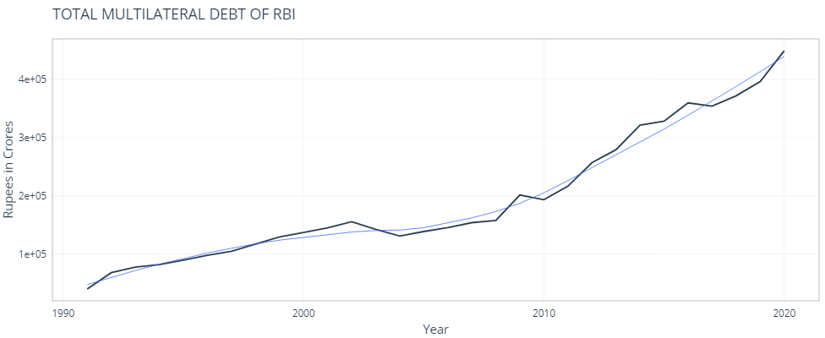**Total Multilateral Debt.**
2. **Total Bilateral Debt.**

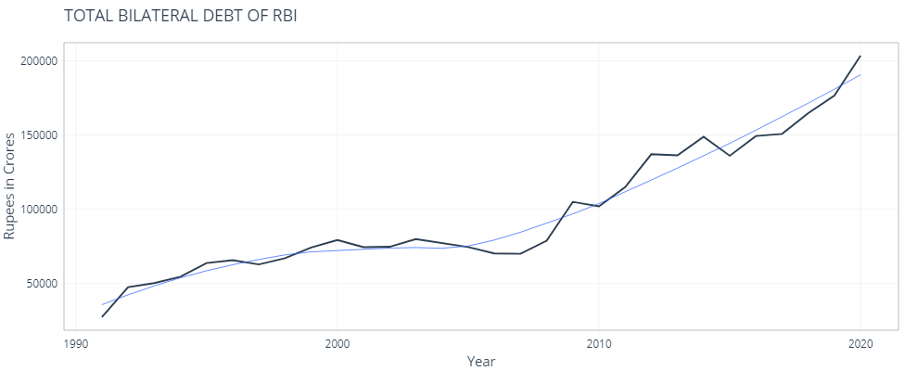

1. 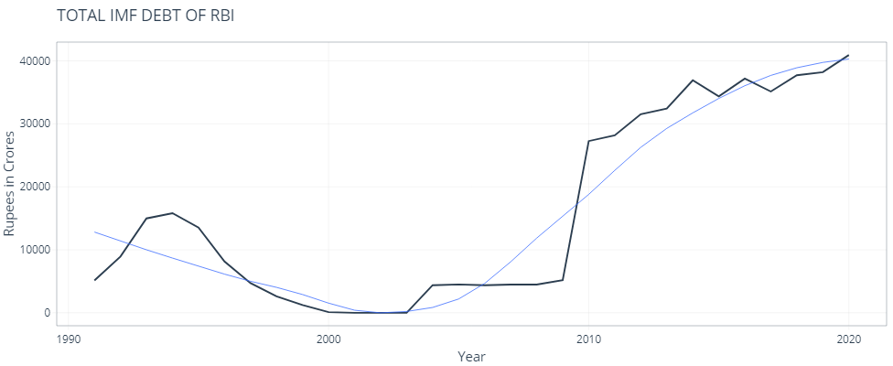**IMF (International Monetary Fund) Loans.**
2. **Total Trade Credit.**

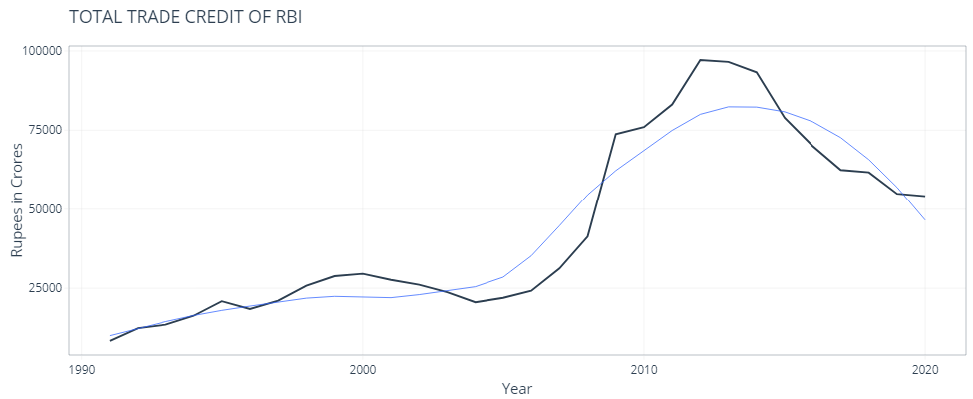

1. **Total Commercial Borrowing.**

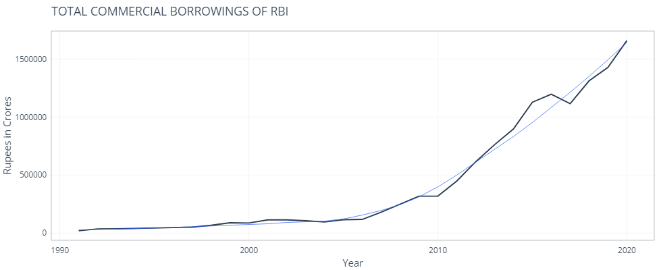

1. **NRI and FC Deposit.**

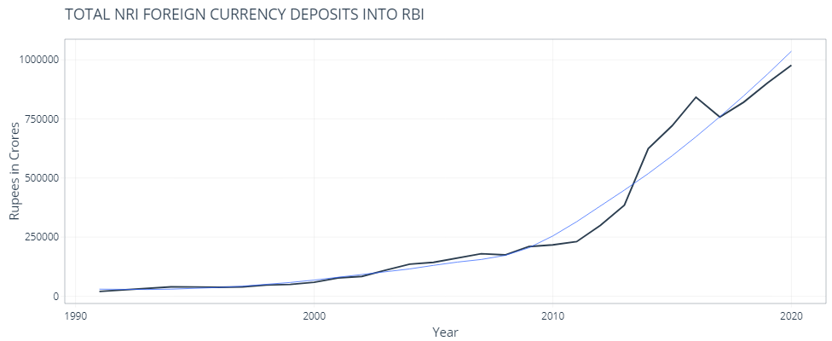

1. **Total Rupee Debt.**

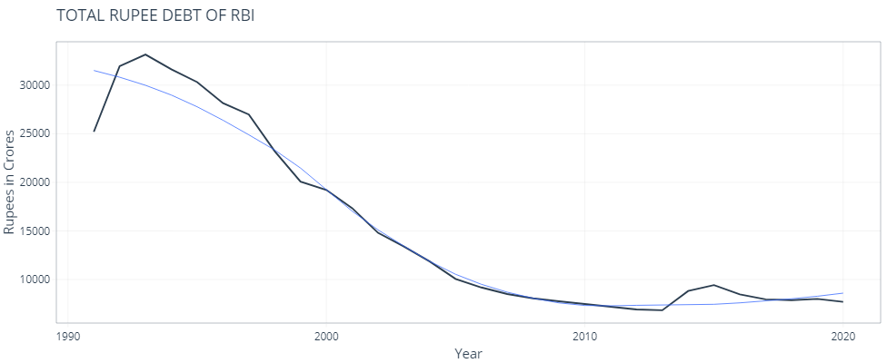

1. **Total Long Term Debt.**

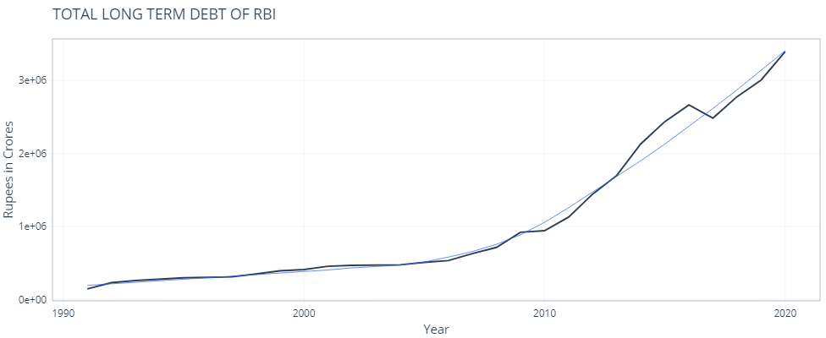

1. **Total Short Term Debt.**

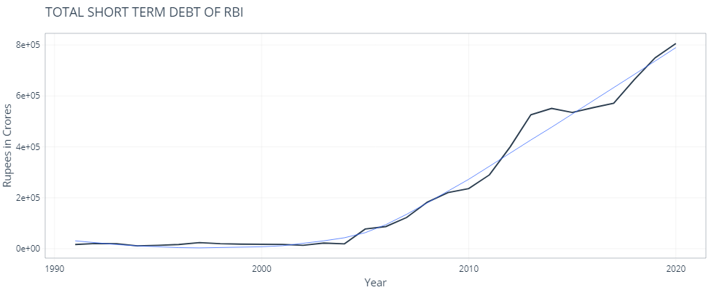

1. **Gross Total Debt.**

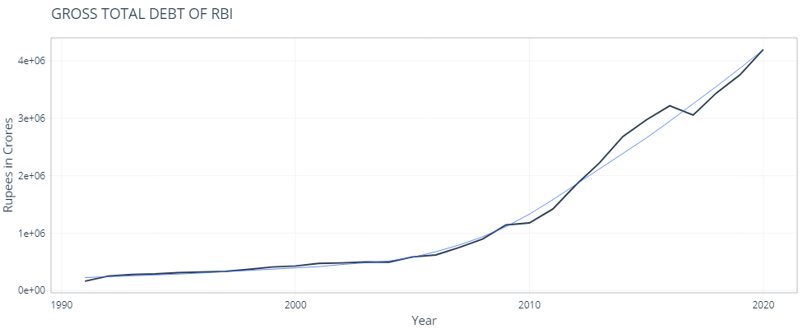

1. **Debt Stock GDP Ratio.**

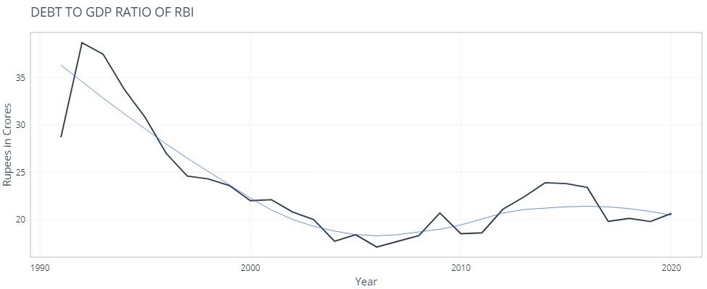

1. **Debt Service Ratio.**

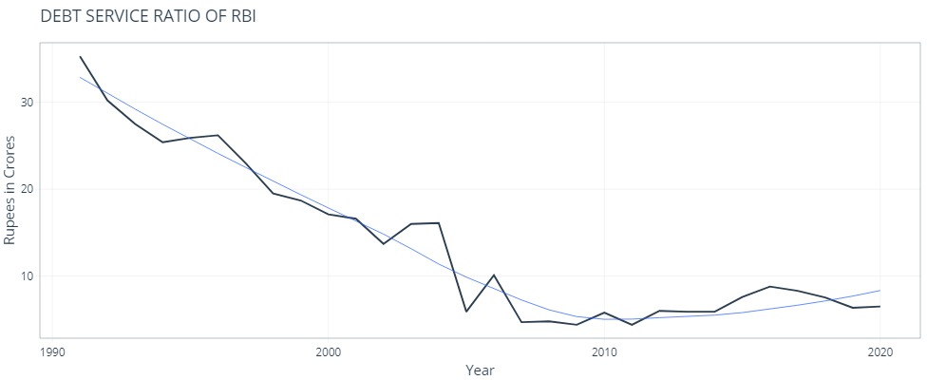

**APPENDIX B**

(Refers to para 7(b))

**KEY CHECKPOINT DATA FOR EACH VARIABLE**

| **Sl No** | **Variable** | **ADF Test value before making training data stationary** | **ADF Test value after making training data stationary** | **Plot of stationary series** | **ACF plot of the stationary series** | **PACF plot of the stationary series** | **ARIMA Model applied**  **(p,d,q)** | **Plot of residuals after application of ARIMA Model** | **Fitting of Model** |
| --- | --- | --- | --- | --- | --- | --- | --- | --- | --- |
| 1 | I_Total_Multilateral | 0.99 | 0.02325 |  |  |  | (0,1,0) |  |  |
| 2 | II_Total_Bilateral | 0.9662 | 0.01881 |  |  |  | (1,2,0) |  |  |
| 3 | III_International_Monetary_Fund | 0.9274 | 0.04627 |  |  |  | (0,1,0) |  |  |
| 4 | IV_Total_Trade_Credit | 0.6865 | 0.01 |  |  |  | (0,2,0) |  |  |
| 5 | V_Total_Commercial_Borrowing | 0.99 | 0.01 |  |  |  | (0,2,0) |  |  |
| 6 | VI_NRI_FC_Deposits | 0.99 | 0.01 |  |  |  | (0,7,0) |  |  |
| 7 | VII_Total_Rupee_Debt | 0.99 | 0.0196 |  |  |  | (1,1,0) |  |  |
| 8 | VIII_Total_Long_Term_Debt | 0.99 | 0.01 |  |  |  | (1,4,0) |  |  |
| 9 | IX_Total_Short_term_Debt | 0.99 | 0.01 |  |  |  | (0,3,1) |  |  |
| 10 | Gross_Total_Debt | 0.99 | 0.01 |  |  |  | (0,3,0) |  |  |
| 11 | Debt_Stock_GDP_Ratio | 0.9077 | 0.0177 |  |  |  | (0,1,0) |  |  |
| 12 | Debt_Service_Ratio | 0.9598 | 0.01 |  |  |  | (0,1,0) |  |  |

**APPENDIX C**

(Refers to para 7(c))

**FORECASTS FOR EACH VARIABLE**

| **Sl No** | **Variable** | **Forecast for 2 years** | **Forecast for 5 years** | **Forecast for 10 years** |
| --- | --- | --- | --- | --- |
| 1 | I_Total_Multilateral |  |  |  |
| 2 | II_Total_Bilateral |  |  |  |
| 3 | III_International_Monetary_Fund |  |  |  |
| 4 | IV_Total_Trade_Credit |  |  |  |
| 5 | V_Total_Commercial_Borrowing |  |  |  |
| 6 | VI_NRI_FC_Deposits |  |  |  |
| 7 | VII_Total_Rupee_Debt |  |  |  |
| 8 | VIII_Total_Long_Term_Debt |  |  |  |
| 9 | IX_Total_Short_term_Debt |  |  |  |
| 10 | Gross_Total_Debt |  |  |  |
| 11 | Debt_Stock_GDP_Ratio |  |  |  |
| 12 | Debt_Service_Ratio |  |  |  |

**REFERENCES**

1. MSc BDA Notes on ARIMA.

2. Forecasting with R – A practical workshop by Nikolaos Kourentzes and Fotios Petropoulos. <https://kourentzes.com/forecasting/wp-content/uploads/2016/06/Forecasting-with-R-notes.pdf>

# 3. Introduction to Forecasting with ARIMA in R. <https://blogs.oracle.com/ai-and-datascience/post/introduction-to-forecasting-with-arima-in-r>

# 4. ARIMA Model – Complete Guide to Time Series Forecasting in Python. <https://www.machinelearningplus.com/time-series/arima-model-time-series-forecasting-python/>

# 5. Stationarity and Non-stationary Time Series with Applications in R. <https://boostedml.com/2020/05/stationarity-and-non-stationary-time-series-with-applications-in-r.html>

# 6. [Applied Time Series Analysis for Fisheries and Environmental Sciences](https://nwfsc-timeseries.github.io/atsa-labs/) - E. E. Holmes, M. D. Scheuerell, and E. J. Ward. <https://nwfsc-timeseries.github.io/atsa-labs/>

# 7. Stationarity testing using the Augmented Dickey-Fuller test - [Willie Wheeler](https://medium.com/@willie.wheeler?source=post_page-----8cf7f34f4844--------------------------------). <https://medium.com/wwblog/stationarity-testing-using-the-augmented-dickey-fuller-test-8cf7f34f4844#:~:text=ADF%20is%20a%20statistical%20hypothesis%20test.%20Without%20going,noise%2C%20we%20expect%20to%20see%20a%20low%20p-value>.

# 8. COMPARING ADF TEST FUNCTIONS IN R - [Fabian Kostadinov](https://fabian-kostadinov.github.io/). <https://fabian-kostadinov.github.io/2015/01/27/comparing-adf-test-functions-in-r/>

9. How to Test the stationarity of a time series with R software - Idriss Tsafack. <https://www.idrisstsafack.com/post/how-to-test-the-stationarity-of-a-time-series-with-r-software>

# 10. DIFFERENCE FUNCTION IN R – DIFF(). <https://www.datasciencemadesimple.com/difference-function-in-r/#:~:text=Difference%20function%20in%20R%20-diff%20%28%29%20returns%20suitably,in%20a%20dataframe%20in%20R%20using%20diff%20function>.

# 11. Plotting ts objects. <https://cran.r-project.org/web/packages/ggfortify/vignettes/plot_ts.html>

# 12. Forecasting: Principles and Practice (2nd ed)- Rob J Hyndman and George Athanasopoulos. <https://otexts.com/fpp2/>

13. RBI Website. [https://dbie.rbi.org.in/DBIE/dbie.rbi?site=publications#!16](https://dbie.rbi.org.in/DBIE/dbie.rbi?site=publications%23!16)